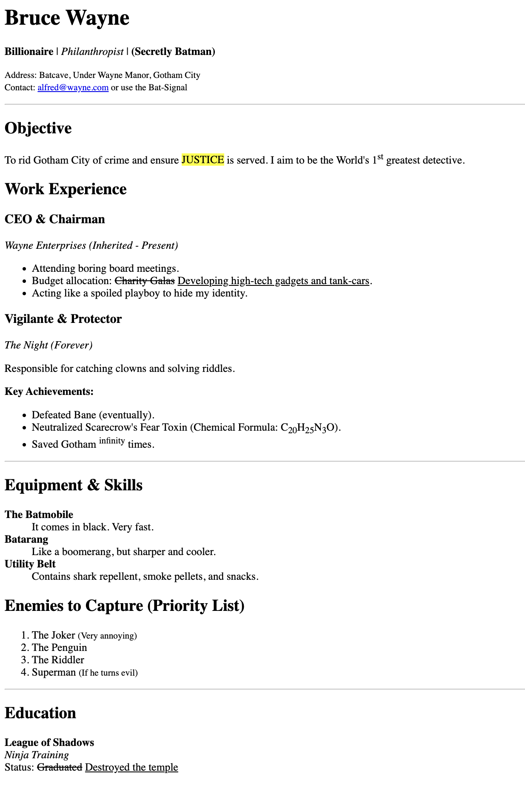

🦇 Mission: The Dark Knight's Resume
Difficulty: Beginner
Topic: HTML Structure, Formatting, and Lists

📝 Scenario
Bruce Wayne needs a resume just in case Wayne Enterprises goes bankrupt. However, he accidentally included some secret details about his life as Batman!
Your task: Recreate his CV exactly as described below using only HTML. Do not use CSS.

🔨 Step-by-Step Instructions

Part 1: The Document Skeleton
- Create a new file named index.html.
- Set up the standard HTML structure: <!DOCTYPE html>, <html>, <head>, and <body>.
- In the <head>, set the Title of the page to: CV - The Dark Knight.

Part 2: The Header
- Inside the <body>, create a <div> for the header.
- Use an <h1> tag for the name: Bruce Wayne.
- Add a paragraph <p> with his roles. Use formatting tags to match this style:
  - Billionaire (Bold)
  - Philanthropist (Italic)
  - (Secretly Batman) (Strong importance)
- Add contact info using <small> tags:
  - Create an email link (<a>) for alfred@wayne.com.
  - Add a title attribute to the link that says: "Alfred checks my emails".

Part 3: The Objective
- Add a horizontal line (<hr>) to separate sections.
- Create a new <div>. Add an <h2> heading: Objective.
- Write the paragraph. You must use:
  - The <mark> tag to highlight the word JUSTICE.
  - The <sup> tag to fix the "st" in 1st.

Part 4: Work Experience (Lists & Formatting)
- Create a new <div> with an <h2> heading: Work Experience.
- Job 1 (Wayne Enterprises):
  - Use an Unordered List (<ul>) for his duties.
  - In the second list item (<li>), use <del> to cross out "Charity Galas" and <ins> to underline "Developing high-tech gadgets...".
- Job 2 (The Night):
  - Create a list item about neutralizing "Scarecrow's Fear Toxin".
  - You must use the <sub> tag for the numbers in the chemical formula: C₂₀H₂₅N₃O.
  - Use <sup> to make the word infinity appear higher than the text.

Part 5: Equipment (Description Lists)
- Create a new section for Equipment & Skills.
- This is a list of terms and definitions. Use the Description List tag (<dl>).
  - Use <dt> for the item name (e.g., The Batmobile).
  - Use <dd> for the description (e.g., It comes in black).
  - Add entries for: Batmobile, Batarang, and Utility Belt.

Part 6: Enemies Priority (Ordered List)
- Create a section called Enemies to Capture.
- This list needs to be numbered. Use the Ordered List tag (<ol>).
- List the enemies: Joker, Penguin, Riddler, Superman.
- Use <small> tags inside the list items to add funny notes (e.g., "(Very annoying)").

Part 7: Education & Footer
- Add one final <hr>.
- Under Education, describe his "Ninja Training".
- Use <del> to cross out Graduated and <ins> to add Destroyed the temple.

✅ Checklist for Success
Before submitting, check your code:
- [ ] Did you use <ul>, <ol>, and <dl> correctly?
- [ ] Is "JUSTICE" highlighted yellow?
- [ ] Are the chemical numbers (20, 25) small and at the bottom?
- [ ] Does the email link have a tooltip when you hover over it?
- [ ] Are there horizontal lines separating the sections?
Good luck, Detective! 🦇

